Dignity: Priority #1
Our passion is to restore dignity to children in crisis as they enter the foster care system. We continue to support our foster care community by providing ongoing shopping opportunities on a semi-annual basis.

The Big Picture:
We provide a safe, clean, child focused environment for case managers and/or Foster Parents to bring children during those first hours of entering the Foster Care system. Our cozy, quiet and welcoming store is designed to allow for a shopping experience one would have in a typical retail establishment while providing them the dignity and comfort of being able to select clothing and accessories that match their needs, preferences and comfort levels.
Service Hours
Monday: 3 P.M. – 7 P.M.
Tue. & Thur: 3 P.M. – 7 P.M.
Saturday: 10 A.M. – 2 P.M.
Other In-Person shopping times by appointment or shopping via Zoom is now available. Just contact Tracy at tracysoto@fostercarecloset.org or by calling (308)-641-5516.

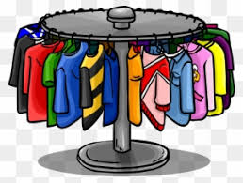

Foster CARE
Closet 1818 Broadway
Scottsbluff
(308)-641-5516

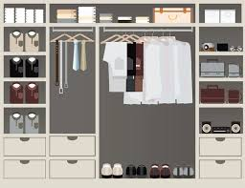

Quality Products!
Quality Counts and the Foster CARE Closet carries the same brand new, name brand merchandise e.g. Carters, Old Navy, Jumping Beans, So Nike and others sourced the same way as is done by major retail chains.

The First Visit:
Children being placed into Foster Care will receive five (5) full outfits, under garments and shoes as well as needed seasonal items such as coats.

Moving Forward:
Twice annually, on a Spring/Summer and Fall/Winter timeline foster children are again entitled to shop for five (5) full outfits, shoes and undergarments as well as items specific to the season at hand.

And There’s More!
On a regular basis Foster Closet shoppers can also find school supplies, stuffed animals, personal hygiene items, warm comforting blankets, backpacks and more!

Foster CARE Closet
The Foster CARE Closet is a nonprofit organization and all services and products are provided free of charge to Foster Children.
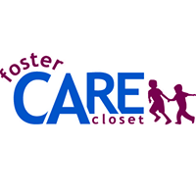

Easy Access!
Our services are easy to use. To honor the dignity of children we want them to have the experience of selecting what they wear in person. However, we know that for a variety of reasons, including the 9,000 square mile service area we serve that there are challenges to this. Call Tracy to set up a Zoom session and shop from home.

